## Bandwidth Constraints.

## Room SID - RM8f8126ea659ca29453fafaa200164048

## 

## 

## Codec Preference

## Room SID - RMb5e59c0875adf959000df923a6f77971

## 

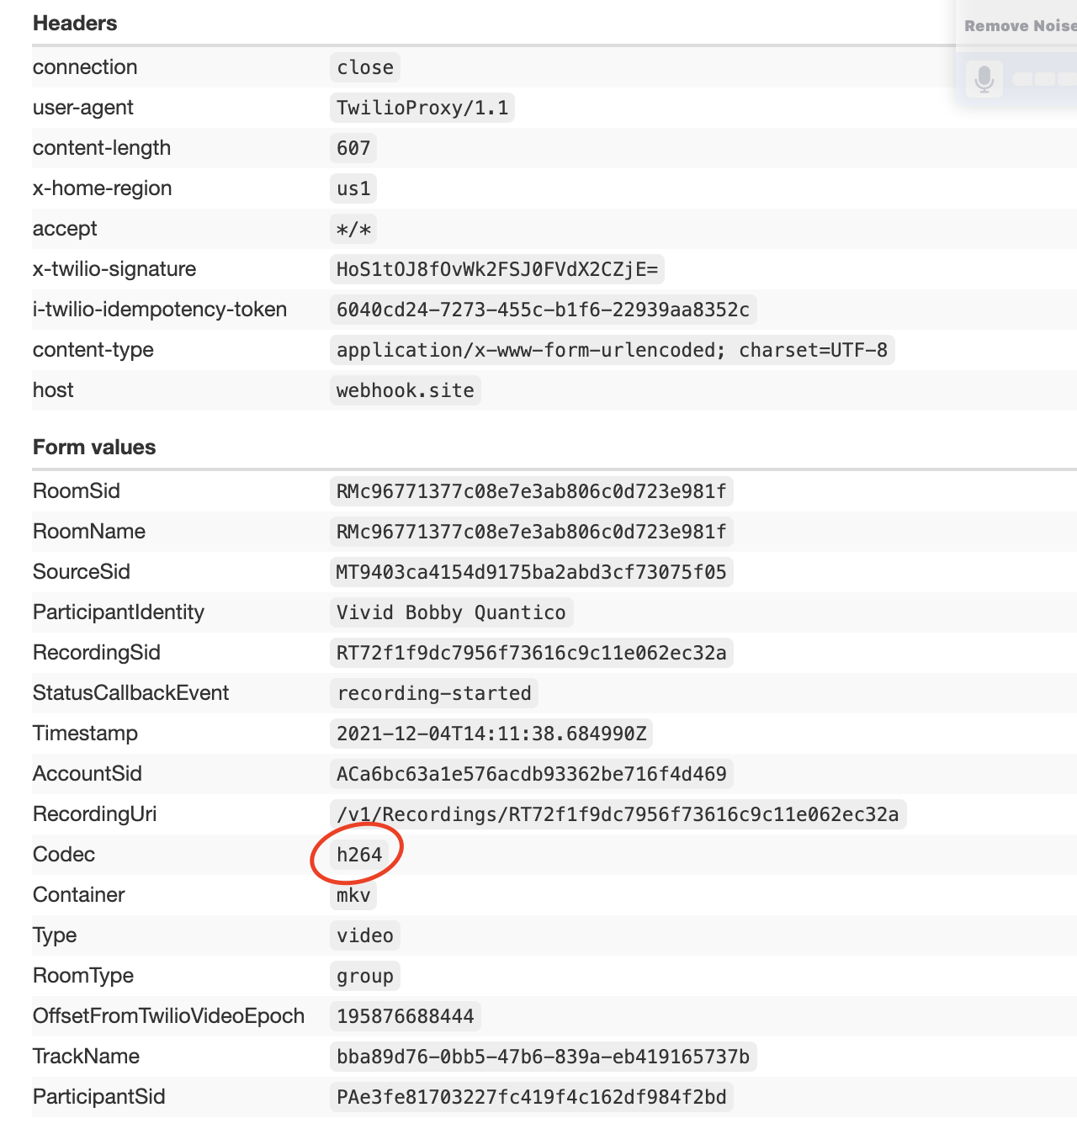

## 

## Video Snapshot

## Room SID - RMb5e59c0875adf959000df923a6f77971

## 

## 

## Dominant speaker detection

## RMf0365e93393fb9e9578edb6832899617

## 

## 

## 

## Network Quality

## Room SID - RM973df5ab0cbd2dad42d4f0241a7d8e3c

## 

## 

## 

## Remote participants reconnection states.

## Room SID - RM7060ecbf317d8e7cf0ddc815971d8ee9

## 

## 

## 

## 

## Media device selection -

## Room SID - RM499643a80972269546db34208547989b

## 

## 

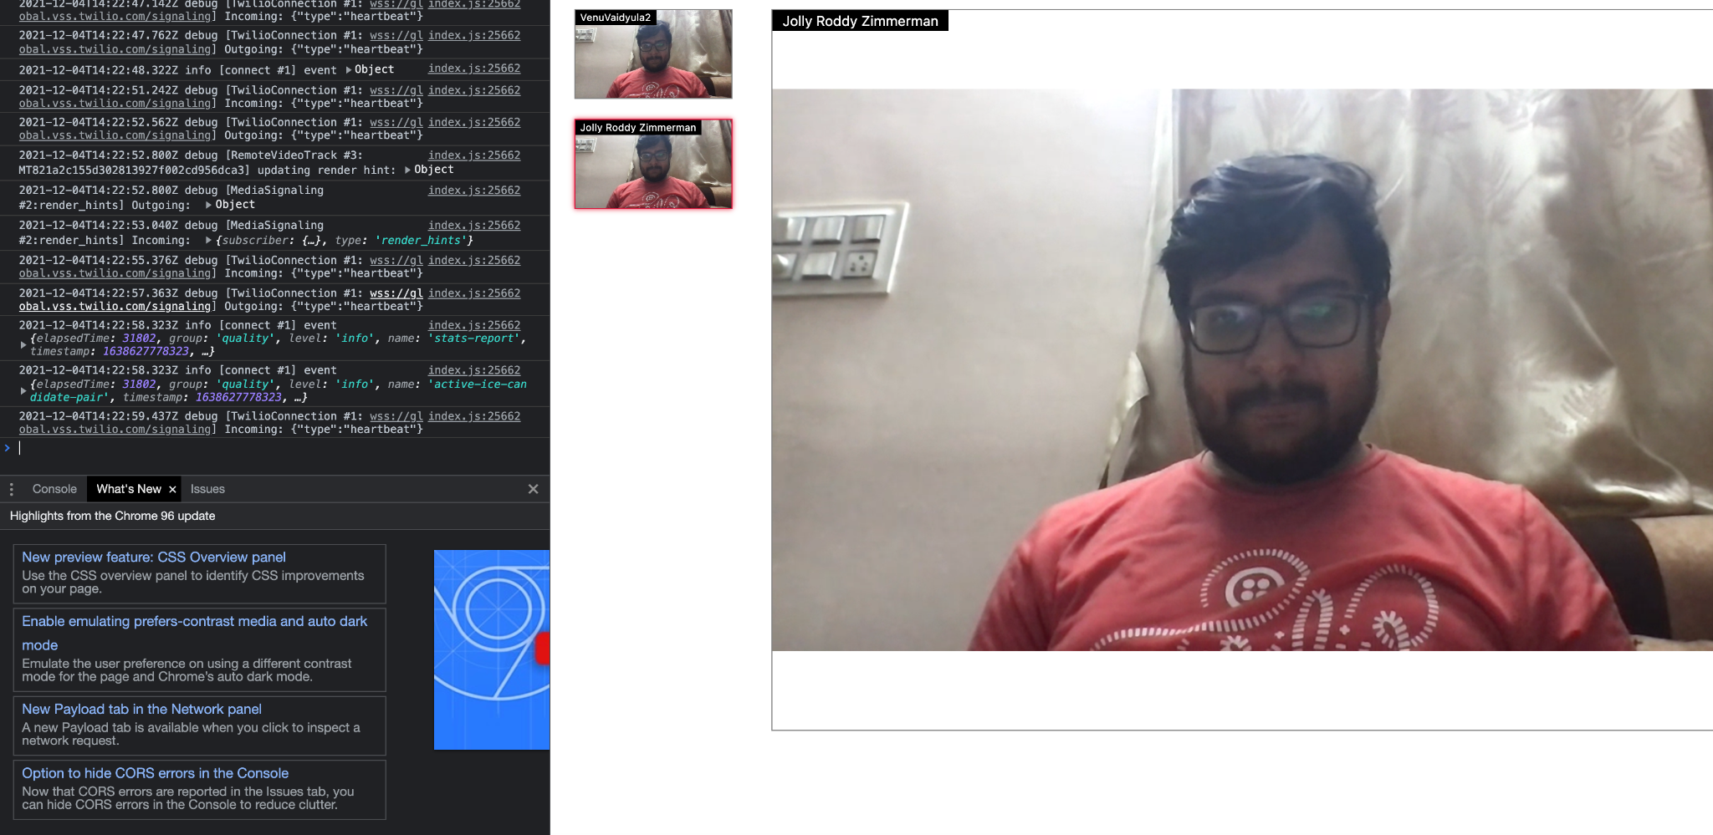

## 

## Screen share

## RMd5ad3a9ea52a7d47d803d9ff1da226eb

## 

## 

## Reconnection states and events

## SID - RM36abc5185b62d335aebd503c7ce07108

## 

## 

## 

## 

## 

## 

## 

## 

## Enabling and disabling tracks

## Room SID - RMceb6d5da962d162e9606d7dfcc230ca6

## 

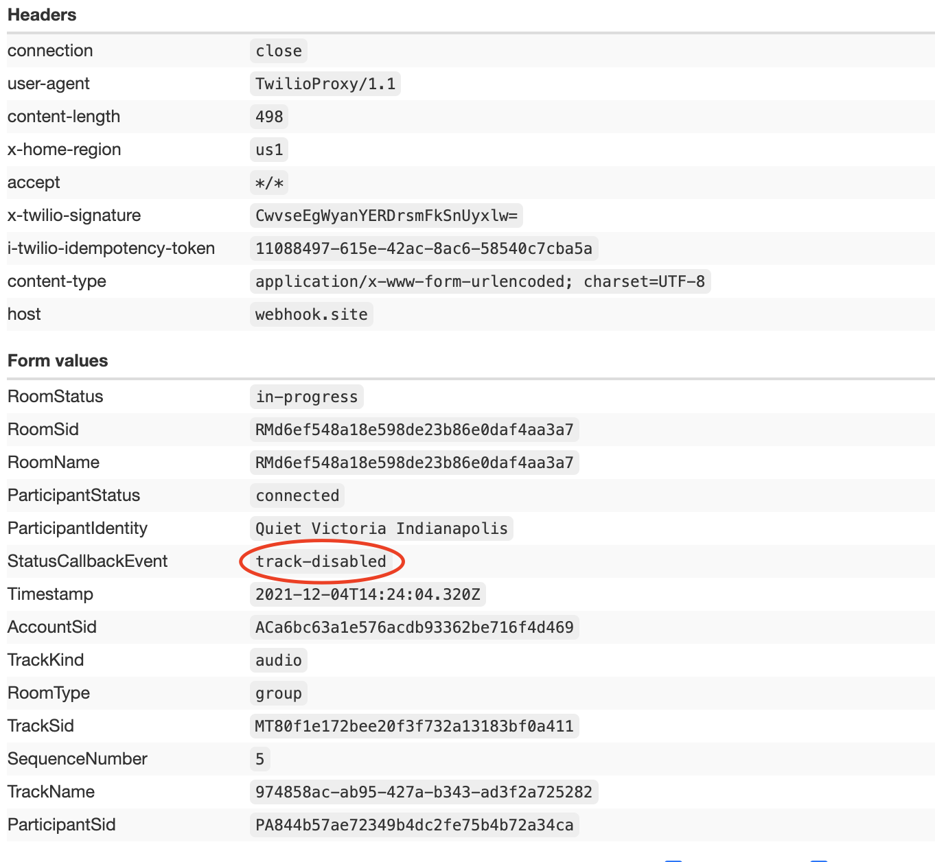

## 

## Data Tracks

## Room SID - RM3f929849c676dd3d832585db82bac0b6

## 

## 

## Video Track automatic controls

## Room SID - RMe384845fae6bb588c0f99c290568bca9

## 